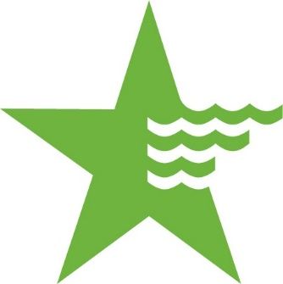
CAW SUPPLIER DIVERSITY & INCLUSION

RESOURCES

thesupplierclearinghouse.com

Click Search Directory to find diverse vendors.

Learn more about General Order-156
http://docs.cpuc.ca.gov/Published/General_order/59939.htm

http://www.thesupplierclearinghouse.com/about_us.html

CAW Supplier Diversity & Inclusion | Business Outreach Video
https://www.youtube.com/watch?v=WM8ubDNjq6c&feature=youtu.be

Direct primes and subcontractors to The Supplier Clearinghouse
http://www.thesupplierclearinghouse.com

Our “how to do business with us” instructions
https://amwater.com/caaw/about-us/doing-business-with-us/supplier-diversity

Our Tier 2 Reporting System
https://amwater.diversitycompliance.com/FrontPage/DiversityMain.asp?XID=5862
**please submit your quarterly Tier 2 DBE spend report even if the amount is zero**

Supplier Clearinghouse | Contact Information

10100 Pioneer Blvd, Suite 103
Santa Fe Springs, CA 90670
info@thesupplierclearinghouse.com | www.thesupplierclearinghouse.com

PHONE: (562) 325-8685 | (800) 359-7998 (8am - 5pm Pacific Time)
FAX: (562) 278-0153 & (888) 549-3803

Edward Simon

Director, Business Performance, Supplier Diversity

619-721-9524

Edward.simon@amwater.com

